**Home**

New Logo:

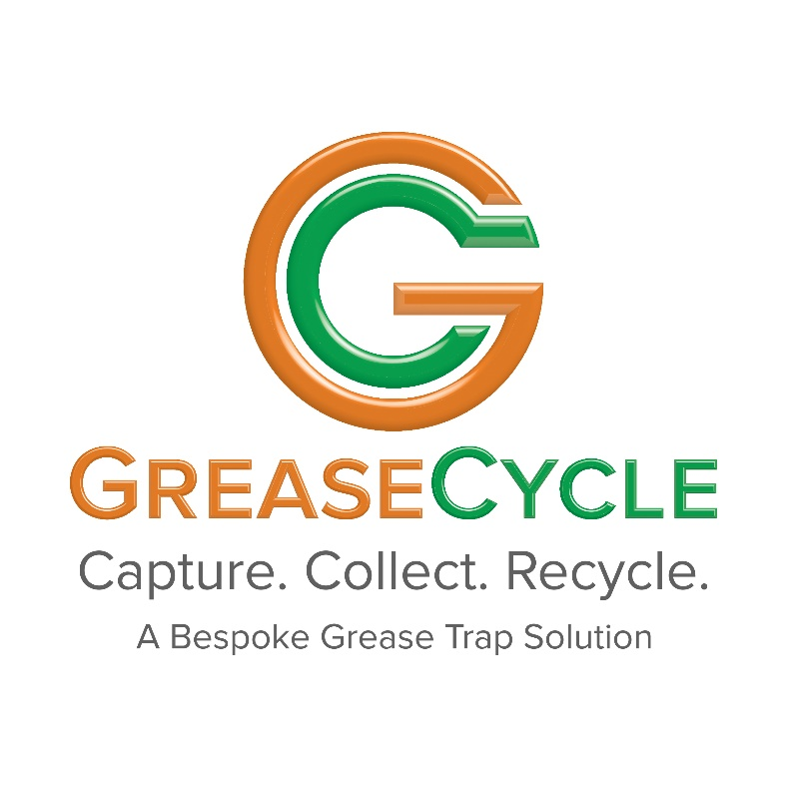

**What is GreaseCycle?**

New images of current installations:

Either a slideshow (if possible) or just pick whichever one looks the best in your opinion.

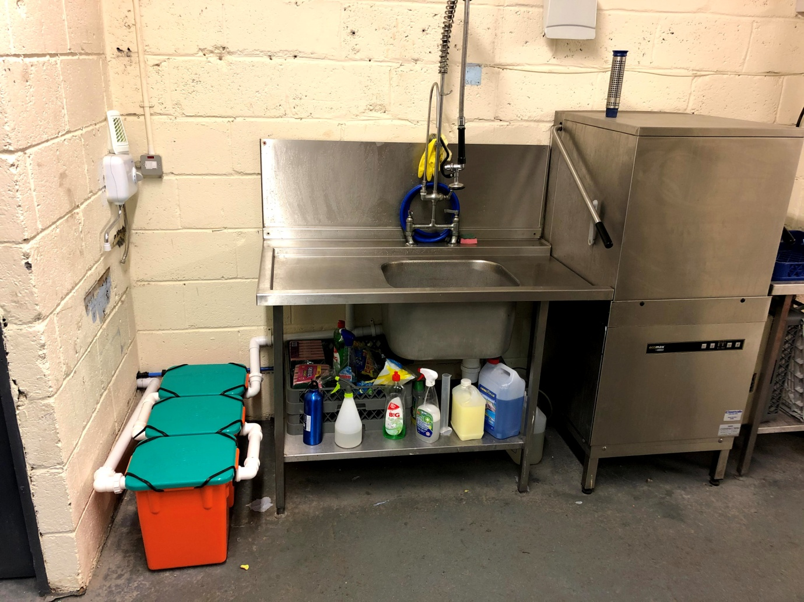

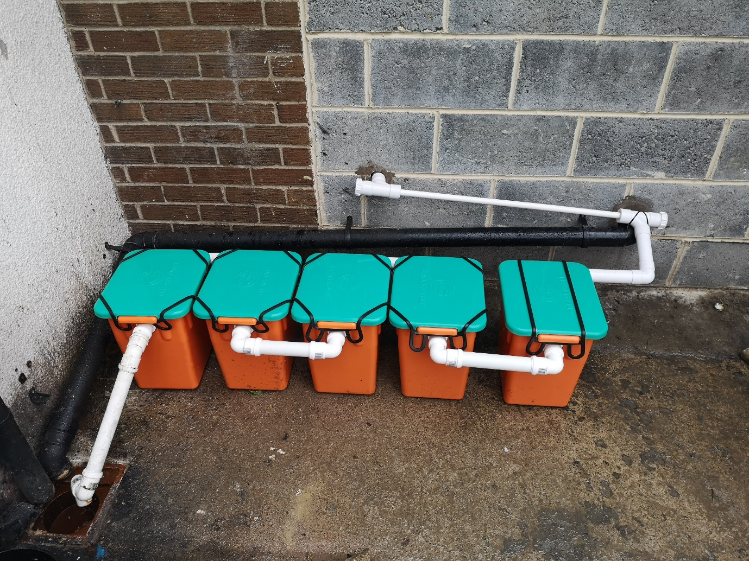

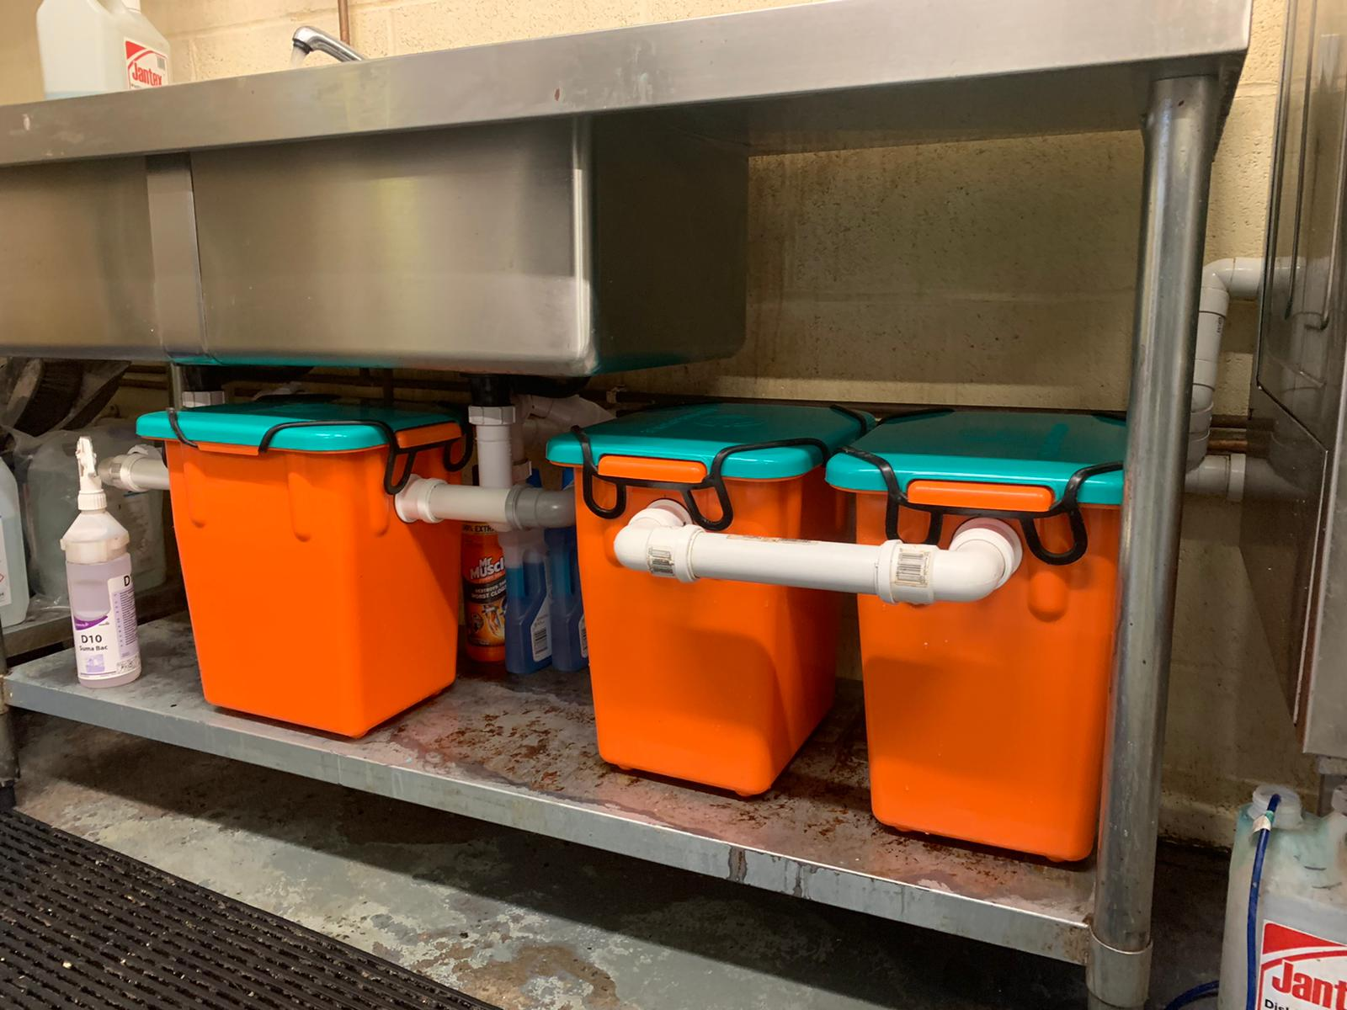

Below “GreaseCycle provide a hassle free grease management service for commercial kitchen”, In place of “We provide a hassle free service from installation through to monthly replacements”, put this:

* Installation
* Monthly replacements
* Waste disposal
* Ongoing customer support

All of this for an affordable monthly fee Starting from as little as

**£69.99 per month**

*(Excl. VAT)*

**About Us**

GreaseCycle is a fully managed grease trap leasing service for commercial kitchens. Our grease traps are designed and manufactured in the UK and our unique modular design ensures we can accommodate kitchens of all shapes and sizes.

Rather than a fit and forget approach used by most grease trap companies, GreaseCycle continue to support your business following installation by replacing the grease trap system on a monthly basis with clean sanitised modules.

This ensures that your grease trap continues to work effectively without you having the hygiene risk of cleaning it out in the middle of your kitchen. The FOG captured in the modules is collected and recycled for Biofuel to help lower your carbon footprint and be more environmentally friendly.

**The Problem**

New background image:

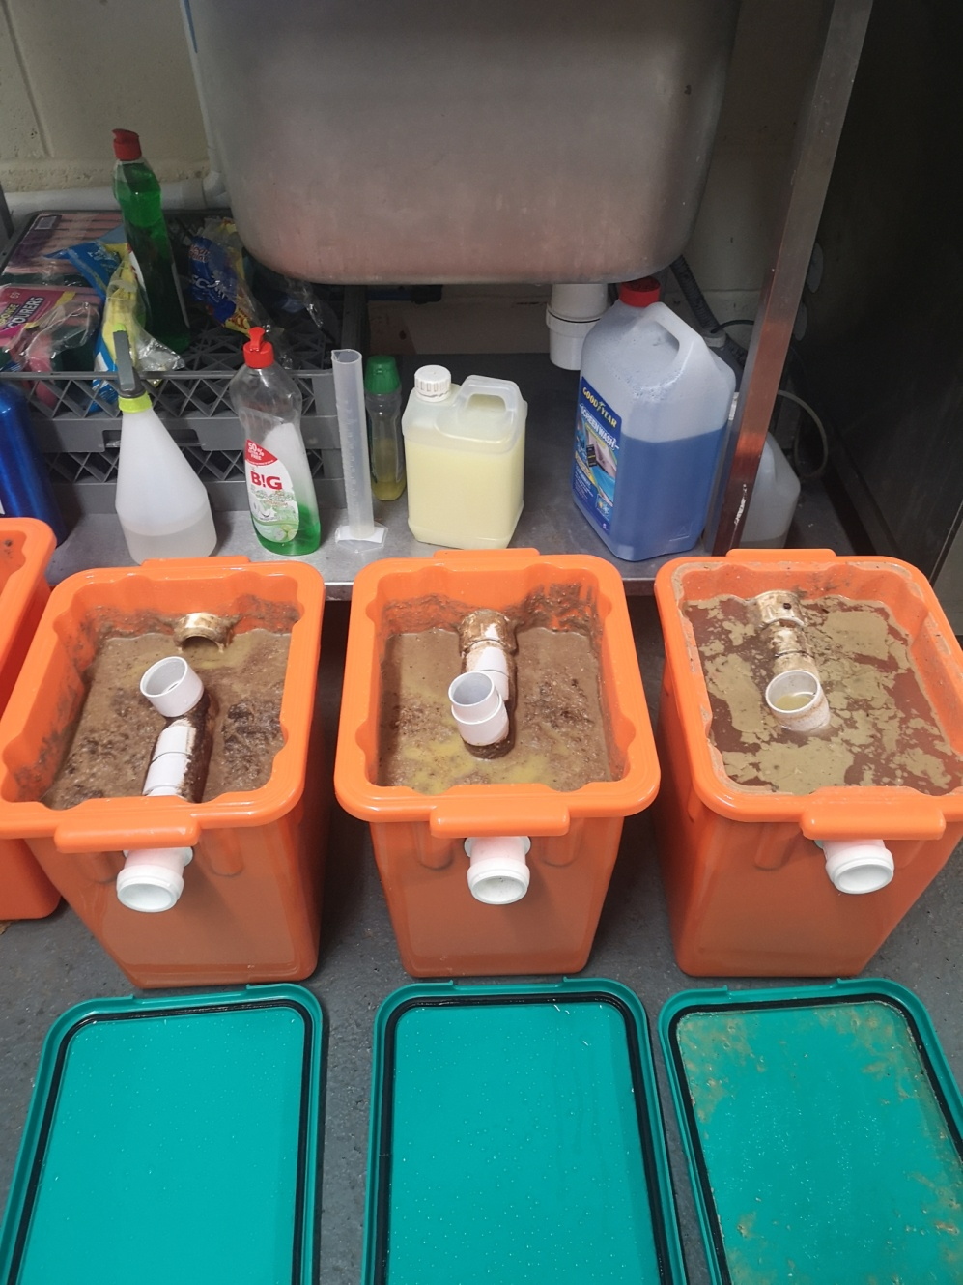

Just add the following, including hyperlink, at the end (after prosecution...): under [section 111 of the Water Industry Act](http://www.legislation.gov.uk/ukpga/1991/56/section/111).

**Why GreaseCycle? (Instead of “The Solution”)**

* **Hassle Free** - Monthly replacements by a trained technician
* **Improved Drainage** - Avoid blockages and bad odours
* **Peace of Mind** - Ongoing support to avoid potential fines
* **Environmentally Friendly** - Fat, oil and grease recovered from our grease traps is recycled for biofuel

Contact us today for a free, no obligation consultation…

**Contact us**

No changes